

CHRIST (Deemed to be University) Bengaluru – 560029
School of Business Management
Pune – Lavasa Campus

PYTHON FOR DATA ANALYSIS (MBA 342B)

FINAL PROJECT REPORT

(Topic: Stock Market Movement Prediction Using Sentiment Analysis)

Submitted By: Diksha Pandey
Register No: 25121016
Class: 3MBA BA
Course Code & Name: MBA 342B | Python for Data Analysis
Campus: Pune Lavasa Campus
Submitted To: Dr Himani Saraswat
STOCK MARKET MOVEMENT PREDICTION USING SENTIMENT ANALYSIS
INTRODUCTION:
Stock market prediction is a complex and dynamic problem influenced by multiple factors such as economic indicators, global events, and investor behaviour. In recent years, sentiment analysis—which captures public opinion from news and social media—has gained importance as a factor affecting market trends.
Investors often rely on both quantitative data and qualitative insights while making decisions. This project attempts to bridge that gap by converting sentiment into measurable data and using it to predict market movement.
The study focuses on understanding whether sentiment can act as a reliable indicator of stock market direction and how machine learning can assist in this process.

OBJECTIVE:
The main objectives of this project are:
- To analyse the relationship between sentiment and stock market movement.
- To build a machine learning model that predicts market direction.
- To evaluate the effectiveness of sentiment as a predictive variable.
- To demonstrate how data analytics can support investment decisions.

DATASET DESCRIPTION:
The dataset used in this project consists of structured data with the following variables:
- Date: Represents the timeline of observations and helps in tracking trends over time
- Sentiment Score: Indicates the polarity of sentiment
-1 → Negative sentiment
0 → Neutral sentiment
1 → Positive sentiment
- Movement: Represents stock market direction
0 → Market Down
1 → Market Up

METHODOLOGY:
Data Loading and Preprocessing:
The dataset was imported using the Pandas library. Initial preprocessing steps included:
- Converting the Date column into a datetime format for better handling
- Checking for missing values and data consistency
- Understanding dataset structure using:
  - .info() to examine data types and null values
  - .describe() to obtain statistical summaries such as mean, standard deviation, minimum, and maximum values
These steps ensured that the dataset was ready for further analysis.
Exploratory Data Analysis (EDA):
To gain insights into the data, several visualisations were created:
- Sentiment Distribution:
A bar chart was used to observe how frequently each sentiment category appears. This helps in understanding whether the dataset is dominated by positive, negative, or neutral sentiment.
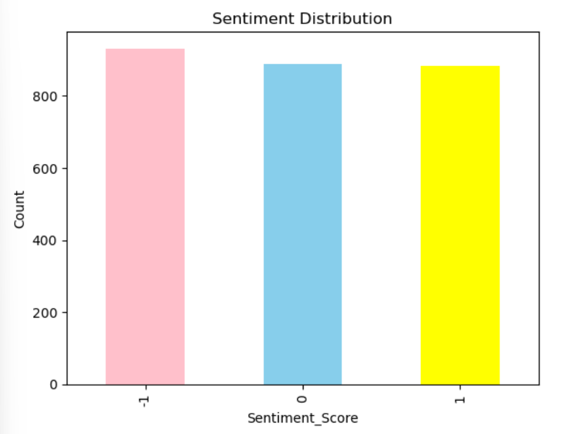
Figure 1: Distribution of Sentiment Scores

- Market Movement Distribution:
This visualisation shows the frequency of upward and downward market movements, helping identify any imbalance in the dataset.
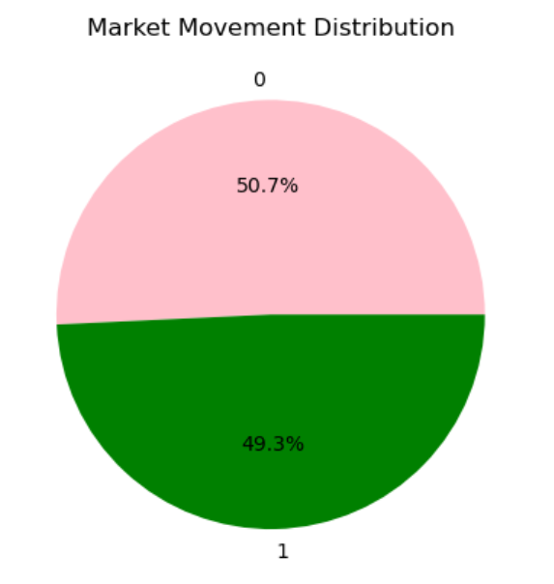
Figure 2: Distribution of Market Movement

- Relationship Analysis (Heatmap):
A heatmap was used to analyse the relationship between sentiment scores and market movement. It visually represents how different sentiment categories are associated with market outcomes.
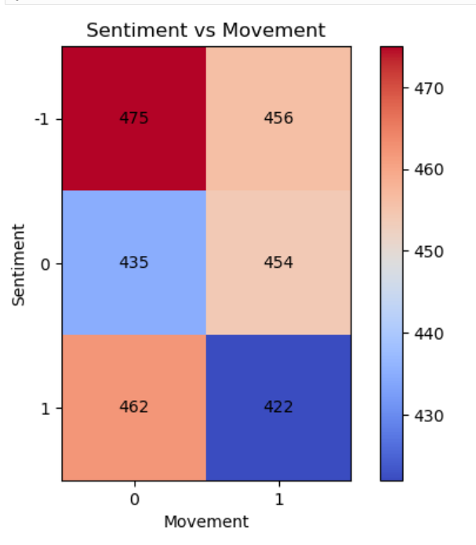
Figure 3: Relationship between Sentiment and Market Movement
Model Building:
A Logistic Regression model was selected for this project due to its effectiveness in binary classification problems.
- Independent Variable (X): Sentiment Score
- Dependent Variable (y): Market Movement
The dataset was divided into:
- Training Set (80%) for building the model
- Testing Set (20%) for evaluating performance
Model Training:
The Logistic Regression model was trained using the training dataset. During training, the model learns the relationship between sentiment scores and corresponding market movements.
This step is crucial as it enables the model to generalize patterns from historical data.
Model Evaluation:
The model’s performance was evaluated using the following metrics:
- Accuracy Score:
Indicates the proportion of correct predictions made by the model
- Classification Report:
Provides detailed performance metrics:
  - Precision: Accuracy of positive predictions
  - Recall: Ability to identify actual positive cases
  - F1-Score: Balance between precision and recall
These metrics help assess the reliability and effectiveness of the model.
Prediction:
To demonstrate practical application, the model was tested using sample inputs:
- A positive sentiment score (1)
- A negative sentiment score (-1)
The model predicts whether the market is likely to move up or down based on these inputs, simulating real-world usage.

RESULTS:
The model successfully predicts stock market movement using sentiment as an input variable.
- The results indicate a noticeable relationship between sentiment and market trends
- Positive sentiment tends to align with upward movement, while negative sentiment aligns with downward movement.

CONCLUSION:
This project demonstrates that sentiment analysis can be a valuable tool in understanding and predicting stock market behaviour.
Although the model used is relatively simple, it is capable of capturing meaningful patterns. The findings suggest that investor sentiment plays a significant role in influencing market trends, and integrating such insights can improve decision-making processes.

LIMITATIONS:
- The model relies on a single feature (Sentiment Score)
- It does not consider other important market variables such as:
  - Stock prices
  - Trading volume
  - Economic indicators
- The dataset may not fully represent real-world complexity

FUTURE SCOPE:
The project can be further enhanced by:
- Incorporating additional data sources:
Financial news
Social media feeds
Historical stock prices
- Applying advanced machine learning techniques:
Random Forest
TOOLS AND TECHNOLOGIES USED:
- Python
- Pandas (data handling)
- Matplotlib (data visualisation)
- Scikit-learn (machine learning)

REFERENCES:
- Scikit-learn official documentation.
- Pandas documentation.
- Research articles on sentiment analysis in finance.

CODES:
